**Course: Advance Bio Informatics**

**Module Title: Genetically Modified Crops**

**Module No: 92**

**Genetically Modified (GM) Crops**

Crops that contain an added gene sequence. Foods that have a deleted gene sequence. Animal products from animals fed GM feed. Products produced by GM organisms.

**Why GM Crops?**

Genetic engineering offers a rapid and precise method of altering organisms as compared to traditional methods that are slow & inaccurate.

**GM Crops**

* Vegetables.
* Tomatoes.
* Potatoes.
* Rice.
* Cheese.
* Meat.

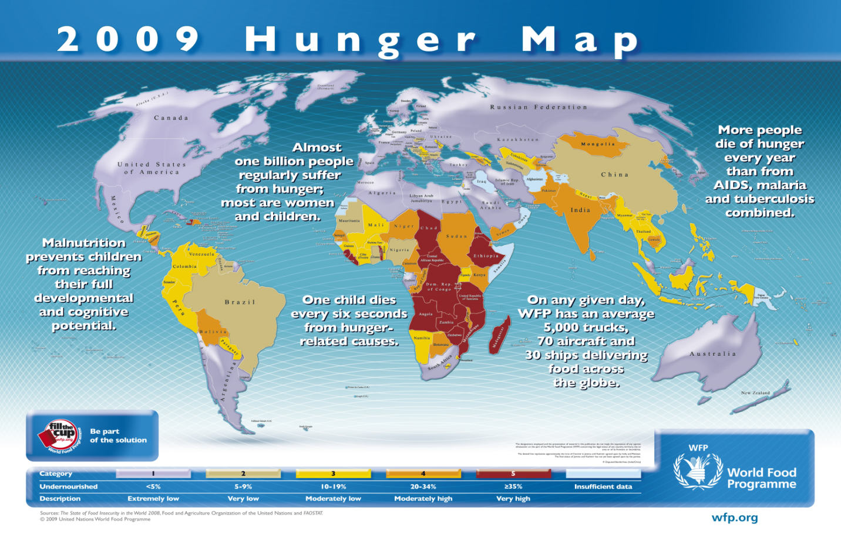

**GM Crops Benefits**

GM crops Ease of world hunger. It helps in development of drought resistant crops. Development of crops that make more efficient use of nitrogen and other nutrients. Improved crop quality. Development of foods designed to meet specific nutritional goals. It assists in development of flood resistant crops.

**Risks of GM Foods**

Certain gene products may be allergens, thus causing harm to human health.

There may be unintended harm to wildlife and beneficial insects.